
CS614
Assignments No-1
SOLVED by: JUNAID MALIK

Question No. 1
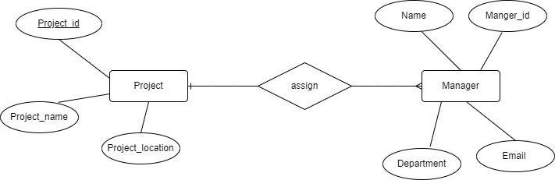
ANSWER:
In this Technique Pre-JOINING de-normalization will be used. Pre-joining technique is used when 1 to Many Relationship Occurs between two or More Table. Such as master-case details when there are header and details tables in the Logical Data Model.
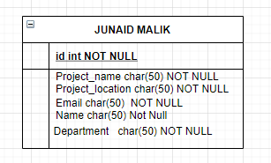
Header Size of the Project table = (30+50-8)
= 72Bytes
Number of records stored in course table = 3000000
= 72*3000000 bytes
= 216,000,000 bytes
= 216,000,000/1000*1000
= 216 MB
= 216/1000 = 0.216 GB = 0.216/1000 = 0.000216 TB

